EAST DEVON DISTRICT COUNCIL
Please complete this sheet where your precept exceeds E140,000, or for those under E 140,000 you may find this sheet helpful to calculate your precept.
Name of Parish Council......CLYST ST GEORGE PARISH COUNCIL Estimated Requirement for the year ending 31st March 2018 is:
*Service | Requirement
Clerk's salary | 2668
Clerk's expenses Clerk's training | 444
 | 50
Petty Cash | 150
Courses DAPC etc | 200
External Accounts — Thomas Westcott | 200
Village Maintenance | 100
Footpaths | 100
Insurance | 700
Grass Cutting | 500
Hall Hire | 200
Neighbourhood Plan | 500
Grants (new policy) | 600
Auditor (external) | 275
TOTAL | 6687
Council Tax Support Grant | 40
Precept Requirement of Council (Round to nearest E) | 6727
Please note the above is purely for guidance. You may wish to enclose your own expenditure details.
Please enter your appropriate Council Tax Support Grant as detailed in Appendix A.
Signed..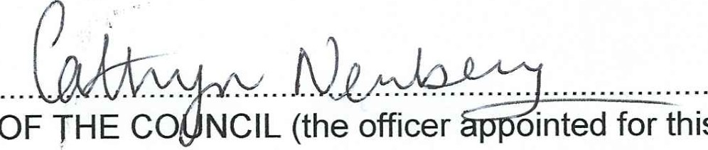 Date..16 January 2017
this
purpose)
CLERK
If requirement is NIL, please state this is so.
Please complete for record purposes only:
Name of Clerk Cathryn Newbery
Address | Mount Grindle, Old Winslade, Clyst St Mary, Exeter EX5 IAS
Telephone | 07740531980

