CLYST ST GEORGE & EBFORD SECTION OF THE APRIL 2019 CLYST VALLEY NEWS
CLYST ST GEORGE AND EBFORD
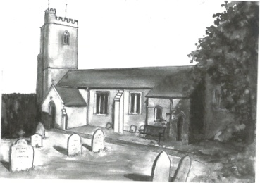
Wednesday Morning Prayers at Clyst St George Church
Join us on 3rd and 17th April at 9.30 am for half an hour of quiet prayer, followed by a short period of fellowship with a cup of tea or coffee. Do come and join us.

Clyst St George Parish Council Chairman’s Report: April 2019
The Parish Council have accepted a generous offer by Paul and Ivor Bragg of some land at the rear of the Village Hall. This will be public open space. The Council will be spending ‘planning gain’ or S106 money on fencing and other improvements so that the school and you can use it.
The PC have now registered www.clyststgeorge.org.uk for our use, and as a community website. We plan to have links and maybe share it with local groups. More details when it is up and running.
If you want to become a Parish Councillor then you have until Wednesday 3rd April to get the forms into EDDC. Polling day is Thursday 2nd May. All the best.
John Manser john@jmanser.co.uk 01392 874861

Coffee Morning at Clyst St George and Ebford Village Hall: Wednesday 3rd April
On Wednesday 3rd April, the Hall committee will be holding a coffee morning 10.30 am – 12 noon. Everyone is welcome; pop in for a tea or coffee and a biscuit for £1.
Get out of the house and socialise with your neighbours (more and more people have).
We will hold these regularly on the first Wednesday of each month.
This Photo by Unknown Author is licensed under CC BY-SA-NC

Ebford Good Neighbours Scheme
The Ebford Good Neighbours Scheme started in December 2017. It provides the type of short- term help you would expect from a friend or neighbour. The volunteers have been DBS checked. They have received advice and training from Westbank League of Friends and the community police. All information is confidential. We provide help such as:
- shopping or picking up a prescription
- pet care such as dog walking or visiting the vet
- letter writing or form filling
- advice on contacting support or help agencies
- small DIY fix-its or just changing a light bulb
If you could do with some neighbourly help or advice please call us on 07522 517900 9 am to 6 pm. Vaughan Rosser, Chairman of Ebford Residents Group

Ebford Neighbourhood Watch
Ebford Residents Group took over the co-ordination of Ebford Neighbourhood Watch in December 2018 with Andrew Teasdale as its coordinator. Ebford residents can join their local scheme by going to www.ourwatch.org.uk and entering their postcode and going into the menu. Residents in other areas can join their local groups in the same way.
Neighbourhood Watch schemes aim to bring neighbours together to create strong, friendly, active communities where crime and anti-social behaviour are less likely to happen.
The goals are to to help residents:
-share advice on home security
-share advice on issues such as personal safety, fire safety, dealing with bogus callers and so on
-become more vigilant
-receive police information on crime trends and other local issues.
A number of insurance companies will give a home insurance discount if you are in a scheme.

Nick Maguire Memorial Quiz Evening
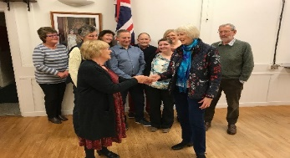
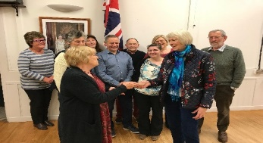
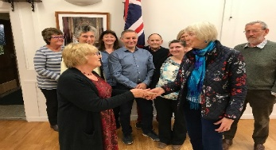
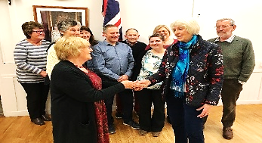
On 2nd March there was a quiz evening held at Clyst St George and Ebford Village Hall to remember fondly Nick Maguire and all the wonderful quiz evenings of which he was the inimitable quizmaster for many years. Who can forget the various hats that Nick wore — a diﬀerent one for each round. And who can forget his beaming smile accompanied by his commanding voice as he maintained his jolly banter while keeping a firm hand on proceedings. It is right to say that the quiz evenings will never be the same but it is also right to say that the hard work put in by the team that led this evening paid oﬀ and a splendid evening was had by all. Those who were there have expressed a hope that it will be the first of many.
And so it was that on 20th March the committee were delighted to be able to hand over a cheque for the sum of £250 in aid of the Exeter Leukaemia Fund to Nick’s widow, Cathy Maguire.

Greetings Cards
We are always grateful to receive cards (except Christmas ones) for remaking and they can be left in the church which is normally open between 9 am and 5 pm each day. Visitors will also find boxes of made up cards for sale covering birthdays, get well, sympathy, new home, thank you, anniversary, etc as well as
cards with no message or wording suitable for any occasion. Do call in and enjoy a few quiet moments browsing and perhaps buy a card. Linda Wilkerson (01392 875705)

Nature Garden
Clyst St George has a delightful nature garden by the side of the parish church. The aim of the garden is to grow local Devon indigenous plants and trees and to encourage a Devon meadow with local wild flowers. Should you wish to help develop this ‘green’ facility, you can come along on the first Saturday of every month from 9.30 to 11 am.

Little Dragons Pre-School
We are pleased with the outcome of our Ofsted inspection in April 2018, where we were judged to be ‘Good’. We still have a few spaces for children so do come and visit and meet our highly experienced staff team. We are based in Lady Seaward’s School and open four days a week, from Monday to Thursday 8.45 am - 3.15 pm during school term times. For more information please telephone Elly on 07939 995486 (in school hours), email littledragons@live.com or visit our website www.littledragonsclyststgeorge.com.

