CLYST ST GEORGE & EBFORD SECTION OF THE FEBRUARY 2019 CLYST VALLEY NEWS

CLYST ST GEORGE AND EBFORD
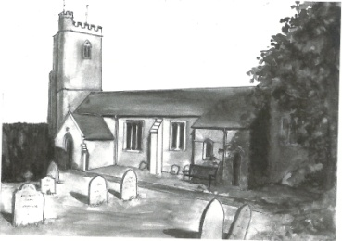
Wednesday Morning Prayers at Clyst St George Church
Join us on 6th and 20th February at 9.30 am for half an hour of quiet prayer, followed by a short period of fellowship with a cup of tea or coffee. Do come and join us.

Clyst St George Parish Council Chairman’s Report February 2019
2019 is already an interesting year. Are you prepared? Can you vote? If you have just moved in or will turn 18 in 2019 then visit EDDC’s website and register to vote (you can opt not to go on the public register). One vote is almost certain, the local elections; the Parish Council’s term is up in May, and some of the District Council. Whilst you are on the East Devon website you can download their app which is very useful - you can check when your bins will be emptied and other information. East Devon’s website also allows you to report fly tipping/litter and that is very efficiently run.
At the January meeting, the Parish Council agreed that we will not increase our precept for 2019/20. CSGG’s precept will cost you just £22.10 on average.
Ebford has restarted its Neighbourhood Watch (see below) which gives you alerts of scams and of crime in the area. It may also give you a discount on your household insurance; do join. If anyone in Clyst St George wants to start a Neighbourhood Watch then contact me and I will pass on details of the Ebford co-ordinator who will brief you on the details.
All the best. John Manser
John Manser john@jmanser.co.uk 01392 874861

Quiz Night
Clyst St George and Ebford Village Hall Committee are holding a Quiz Night on Saturday 2nd March at Clyst St George and Ebford Village Hall. This will be in memory of Nick Maguire, our former secretary, who ran the regular quiz nights and sadly passed away last year. Half of the proceeds raised will be going to Exeter Leukaemia Fund, the other half to the Village Hall Fund. Tickets are £5 a head and teams of up to six are invited to enter - places are limited so book early to avoid disappointment. Bring your own drinks and nibbles. For more information or to book your team, please email clyststgeorgeandebfordvhall@outlook.com or ring 07835 234546. Tickets are also available from Paul Bragg or Helen Cragg in Clyst St George or John Manser in Ebford.
This Photo by Unknown Author is licensed under CC BY

Coffee Mornings at Clyst St George and Ebford Village Hall
On Wednesday 6th February, the Hall committee will be holding a coffee morning 10.30 – 12.30, hosted by John and Jacquie Manser. Everyone is welcome to pop in for a tea or coffee and a biscuit for £1. Get out of the house and socialise with your neighbours. We expect to hold these regularly on the first Wednesday of each month. Do drop in.
This Photo by Unknown Author is licensed under CC BY-SA-NC

Ebford Good Neighbours Scheme
The Ebford Good Neighbours Scheme started in December 2017. It provides the type of short- term help you would expect from a friend or neighbour. The volunteers have been DBS checked. They have received advice and training from Westbank League of Friends and the community police. All information is confidential. We provide help such as:
- shopping or picking up a prescription
- pet care such as dog walking or visiting the vet
- letter writing or form filling
- advice on contacting support or help agencies
- small DIY fix-its or just changing a light bulb
If you could do with some neighbourly help or advice please call us on 07522 517900 9 am to 6 pm. Vaughan Rosser, Chairman of Ebford Residents Group

Ebford Neighbourhood Watch
Ebford Residents Group took over the co-ordination of Ebford Neighbourhood Watch in December 2018 with Andrew Teasdale as its coordinator. Ebford residents can join their local scheme by going to www.ourwatch.org.uk and entering their postcode and going into the menu. Residents in other areas can join their local groups in the same way.
Neighbourhood Watch schemes aim to bring neighbours together to create strong, friendly, active communities where crime and anti-social behaviour are less likely to happen. The goals are to to help residents:
-share advice on home security
-share advice on issues such as personal safety, fire safety, dealing with bogus callers and so on
-become more vigilant
-receive police information on crime trends and other local issues.
A number of insurance companies will give a home insurance discount if you are in a scheme.

Cato
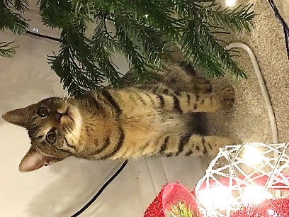
Cato went missing from Seaward Park in Clyst St George during the evening of Saturday 29th December. Cato is a 10 month-old Bengal X with distinctive markings and the typical spotty belly of the Bengal breed. He is similar in colouration to a tabby. He is microchipped and neutered. He is a much loved pet and his family misses him terribly. Please report any sightings to Germaine on 07540 697595.

Greetings Cards
We are always grateful to receive cards (except Christmas ones) for remaking and they can be left in the church which is normally open between 9 am and 5 pm each day. Visitors will also find boxes of made up cards for sale covering birthdays, get well, sympathy, new home, thank you, anniversary, etc as well as
cards with no message or wording suitable for any occasion. Do call in and enjoy a few quiet moments browsing and perhaps buy a card. Linda Wilkerson (01392 875705)

Nature Garden
Clyst St George has a delightful nature garden by the side of the parish church. The aim of the garden is to grow local Devon indigenous plants and trees and to encourage a Devon meadow with local wild flowers. Should you wish to help develop this ‘green’ facility, you can come along on the first Saturday of every month from 9.30 to 11 am.

Little Dragons Pre-School
We are pleased with the outcome of our Ofsted inspection in April 2018, where we were judged to be ‘Good’. We still have a few spaces for children so do come and visit and meet our highly experienced staff team. We are based in Lady Seaward’s School and open four days a week, from Monday to Thursday 8.45 am - 3.15 pm during school term times. For more information please telephone Elly on 07939 995486 (in school hours), email littledragons@live.com or visit our website www.littledragonsclyststgeorge.com.

