**CLYST ST GEORGE & EBFORD SECTION OF THE JULY 2019 CLYST VALLEY NEWS**

**CLYST ST GEORGE AND EBFORD**

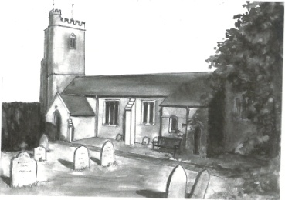

**Wednesday Morning Prayers at Clyst St George Church**

Morning Prayer is a short said service, every other week on a Wednesday. Why not take 20 minutes and join us – we also have tea or coffee afterwards if you have the time? We start at 9.30 am and will meet on 11th and 25th July; it is an opportunity for a short period of calm and fellowship from the mad rush of day to day living.

**CSG Parish Council Chairman’s Report: July 2019**

Planning is still quietbut your Council was pleased to support the   
cricket club’s application for a double practice net, useful for the colts as well as the main teams. The rain and wind in June have meant that brambles and branches have grown out across paths and roads. Could landowners and gardeners trim them back as necessary please? Work on the new website is progressing but the Government has introduced new accessibility requirements, so a delay in our plans.

John Manser [john@jmanser.co.uk](mailto:john@jmanser.co.uk) 01392 874861

**Coffee Morning at Clyst St George and Ebford Village Hall, Wednesday 3rd July**

On Wednesday 3rd July the Hall committee will be holding a coffee morning, 10.30 am – 12 noon. Everyone is welcome ̶ pop in for a tea or coffee and a biscuit for £1. Come and enjoy this sociable event.



[This Photo](http://mikkoriumaplv.blogspot.com/2011_05_01_archive.html) by Unknown Author is licensed under [CC BY-SA-NC](https://creativecommons.org/licenses/by-nc-sa/3.0/)

**Greetings Cards**

We are always grateful to receive cards (except Christmas ones) for remaking and they can be left in the church which is normally open between 9 am and 5 pm each day. Visitors will also find boxes of made up cards for sale covering birthdays, get well, sympathy, new home, thank you, anniversary, etc as well as

cards with no message or wording suitable for any occasion. Do call in and enjoy a few quiet moments browsing and perhaps buy a card. Linda Wilkerson (01392 875705)

**Nature Garden**

Clyst St George has a delightful nature garden by the side of the parish church. The aim of the garden is to grow local Devon indigenous plants and trees and to encourage a Devon meadow with local wild flowers. Should you wish to help develop this ‘green’ facility, you can come along on the first Saturday of every month from 9.30 to 11 am.

**Little Dragons Pre-School**

We are pleased with the outcome of our Ofsted inspection in April 2018, where we were judged to be ‘good’. We still have a few spaces for children so do come and visit and meet our highly experienced staff team. We are based in Lady Seaward’s School and open four days a week, from Monday to Thursday 8.45 am ̶ 3.15 pm during school term times. For more information please telephone Elly on 07939 995486 (in school hours), email littledragons@live.com or visit our website www.littledragonsclyststgeorge.com.