CLYST ST GEORGE & EBFORD SECTION OF THE JUNE 2019 CLYST VALLEY NEWS

CLYST ST GEORGE AND EBFORD
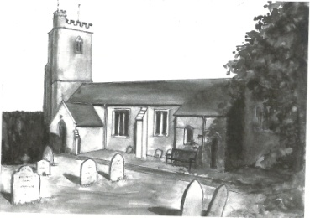
Wednesday Morning Prayers at Clyst St George Church
Join us on 12th and 26th June at 9.30 am for half an hour of quiet prayer, followed by a short period of fellowship with a cup of tea or coffee. Do come and join us.

The Friends of Clyst St George Church Annual Pimms Party
This will be held on Saturday 22nd June 6 – 8 pm in the Church Nature Garden, Clyst St George (Village Hall if wet); there will be canapés and a raffle. Do come; it’s a very enjoyable community event. Tickets are £6, available only in advance from Jacquie Manser on 01392 874861 or Linda Wilkerson on 01392 875705.
This Photo by Unknown Author is licensed under CC BY-SA-NC

CSG Parish Council Chairman’s Report: June 2019
The Parish Council met for the first meeting of its four-year term on Wednesday 8th May. The Councillors are: Paul Bragg, Alan Marks, Andrew Williamson, Geoff Bowen, Dominic Hazell (a new Councillor from Ebford) and myself, and we co-opted Daren Baker to help with the planning. We are all very approachable, so let us know your views on any local issues.
As you will have read, EDDC are now being run by independents but that won’t change the basic planning framework. Our next meeting is on Wednesday 12th June at 7.30 pm in the Village Hall.
A plea from a resident that I mention that dog owners should clear up after their dog, and use the bins provided. Thanks.
John Manser john@jmanser.co.uk 01392 874861

Coffee Morning at Clyst St George and Ebford Village Hall, 5th May
This Photo by Unknown Author is licensed under CC BY-SA-NC
On Wednesday 5th June the Hall committee will be holding a coffee morning 10.30 – 12 noon. Everyone is welcome; pop in for a tea or coffee and a biscuit for £1. Come and enjoy this sociable event.

Greetings Cards
We are always grateful to receive cards (except Christmas ones) for remaking and they can be left in the church which is normally open between 9 am and 5 pm each day. Visitors will also find boxes of made up cards for sale covering birthdays, get well, sympathy, new home, thank you, anniversary, etc as well as
cards with no message or wording suitable for any occasion. Do call in and enjoy a few quiet moments browsing and perhaps buy a card. Linda Wilkerson (01392 875705)

Nature Garden
Clyst St George has a delightful nature garden by the side of the parish church. The aim of the garden is to grow local Devon indigenous plants and trees and to encourage a Devon meadow with local wild flowers. Should you wish to help develop this ‘green’ facility, you can come along on the first Saturday of every month from 9.30 to 11 am.

Little Dragons Pre-School
We are pleased with the outcome of our Ofsted inspection in April 2018, where we were judged to be ‘good’. We still have a few spaces for children so do come and visit and meet our highly experienced staff team. We are based in Lady Seaward’s School and open four days a week, from Monday to Thursday 8.45 am ̶ 3.15 pm during school term times. For more information please telephone Elly on 07939 995486 (in school hours), email littledragons@live.com or visit our website www.littledragonsclyststgeorge.com.

