**CLYST ST GEORGE & EBFORD SECTION OF THE MAY 2019 CLYST VALLEY NEWS**

**CLYST ST GEORGE AND EBFORD**

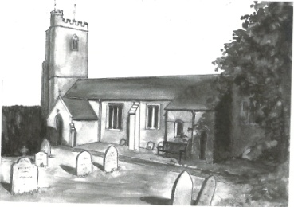

**Wednesday Morning Prayers at Clyst St George Church**

Join us on 1st, 15th and 29th May at 9.30 am for half an hour of quiet prayer, followed by a short period of fellowship with a cup of tea or coffee. Do come and join us.

**CSG Parish Council Chairman’s Report: May 2019**

The Parish Annual Meeting was held on Wednesday 10th April. This meeting is an opportunity for local organisations to let the community know how they are doing and of their plans, and the reports will be on our website. This year, for the first time, we heard from Ebford Residents Group and CSG Cricket Club. The Cricket Club told the meeting of their work, introducing youngsters to the game and then coaching them. This has proved successful with an ex-Colt now opening for Somerset CC. At 125 years old this club is full of life!

There will not be a local election on 2nd May. Six nominations for our seven Parish Council seats; and Mike Howe was uncontested for his seat on EDDC.

The next meeting of the Parish Council is on Wednesday 8th May and will be our AGM; 7.30 pm in the Village Hall.

John Manser [john@jmanser.co.uk](mailto:john@jmanser.co.uk) 01392 874861

**May Day Coffee Morning at Clyst St George and Ebford Village Hall, 1st** M**ay**



[This Photo](http://mikkoriumaplv.blogspot.com/2011_05_01_archive.html) by Unknown Author is licensed under [CC BY-SA-NC](https://creativecommons.org/licenses/by-nc-sa/3.0/)

On Wednesday 1st May the Hall committee will be holding a coffee morning 10.30 – 12 noon. Everyone is welcome to pop in for a tea or coffee and a biscuit for £1. Celebrate May Day with your neighbours.

**Community Tidy Up: Ebford**

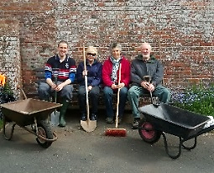On Sunday 14th April a small group of proactive residents came together to complete a 'spring clean' of our local area, donating their free time to remove debris, weeds and litter from the paths and verges of Ebford. Many special thanks to those involved: Anna and John Smith, Ann Deem, Dominic Hazell and Nigel Gulliford for the refreshments! It is our hope to complete a further ‘autumn clean' later in the year.

**Thank you**

Richard Parkinsondied after a long illness on 24th January 2019. Lizzie and the family would like to pass on their huge thanks to everyone for their cards, prayers and support. The collection at his Thanksgiving Service held in late February raised over £1,300 for Demential UK. The money will help fund an Admiral Nurse in the Topsham area. Such nurses support families caring for those living with dementia and are desperately needed.

We are so grateful to you all. Lizzie Parkinson

**Lady Seaward’s C of E primary School**

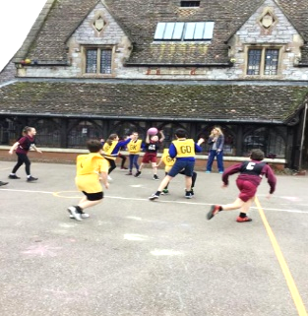Children from across Lady Seaward’s School wowed the staff with a stunning array of wonderful themed costumes linked to their favourite reads! The pupils took part in exciting activities linked to the love of reading including a 'Design the Front Book Cover’ competition, the chance to listen to a teacher perform a dramatic reading of their choosing, 'Drop and Read DPA’ as well as a whole school procession in front of parents at the end of the day. Children from across Key Stage 2 participated in a series of netball games against fellow Central Hub schools, Chudleigh Knighton and Westcliff. Lady Seaward's hosted a fixture against CK where the pupils played two competitive games with both teams demonstrating impressive gameplay with CK coming away with two hard won victories. The team then visited Westcliff to again further develop their play against their fellow hub schools. This time the team came away with an impressive victory against Westcliff and a narrow loss again at the hands of a very talented CK team. We were very proud of all the players who showed great teamwork and determination.

A wonderful Mother’s Day service was held at Clyst St George Church with each class performing a fantastic display of songs and poetry aimed at showing their appreciation to all their mums present. Parents and members of the school community were able to enjoy each performance with a number of heart-warming messages being read out from different children. Each child was also able to say a personal thank you by presenting a bunch of flowers which is always a lovely moment to share.

**Greetings Cards**

We are always grateful to receive cards (except Christmas ones) for remaking and they can be left in the church which is normally open between 9 am and 5 pm each day. Visitors will also find boxes of made up cards for sale covering birthdays, get well, sympathy, new home, thank you, anniversary, etc as well as

cards with no message or wording suitable for any occasion. Do call in and enjoy a few quiet moments browsing and perhaps buy a card. Linda Wilkerson (01392 875705)

**Nature Garden**

Clyst St George has a delightful nature garden by the side of the parish church. The aim of the garden is to grow local Devon indigenous plants and trees and to encourage a Devon meadow with local wild flowers. Should you wish to help develop this ‘green’ facility, you can come along on the first Saturday of every month from 9.30 to 11 am.

**Little Dragons Pre-School**

We are pleased with the outcome of our Ofsted inspection in April 2018, where we were judged to be ‘good’. We still have a few spaces for children so do come and visit and meet our highly experienced staff team. We are based in Lady Seaward’s School and open four days a week, from Monday to Thursday 8.45 am ̶ 3.15 pm during school term times. For more information please telephone Elly on 07939 995486 (in school hours), email littledragons@live.com or visit our website www.littledragonsclyststgeorge.com.