**CLYST ST GEORGE & EBFORD AND LETTERS TO THE EDITOR SECTIONS OF THE NOVEMBER 2019 CLYST VALLEY NEWS**

**CLYST ST GEORGE AND EBFORD**

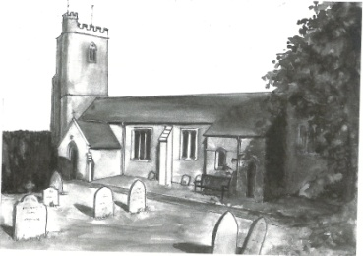**Wednesday Morning Prayers at Clyst St George Church**

Morning Prayer is a short said service, every other week on a Wednesday. Why not take 20 minutes and join us – we also have tea or coffee afterwards if you have the time? We start at 9.30 am and will meet on 13th and 27th November. It is an opportunity for a short period of calm and fellowship from the mad rush of day to day living.

**St George’s Annual Church Autumn Clean-Up 2019**

The annualClyst St George Church clean-up will take place on Sunday 3rd November, 2 to 4 pm. All welcome to come and wield a cobweb broom or polish a pew; alternatively, if you prefer the outdoors you could help tidy the churchyard. Tea and cakes provided!

**Clyst St George & Ebford Harvest Celebration: Thanks**

On behalf of the Clyst St George Parochial Church Council, our thanks to the flower arrangers, Darts Farm, Richards of Topsham for the beautiful vegetables and fruit and to Kenniford Farm for the sausages they donated for the Bangers & Mash Harvest Supper, thoroughly enjoyed by all. Thank you also to those parishioners who donated food for the Supper and everyone’s generosity in raising £235 towards Exeter Food Bank. Paul Bragg and Jacquie Manser (Churchwardens)



[This Photo](https://www.flickr.com/photos/andybullock77/3451014214) by Unknown Author is licensed under [CC BY](https://creativecommons.org/licenses/by/3.0/)

**Coffee Morning at Clyst St George and Ebford Village Hall**

On Wednesday 6th November the Hall committee will be holding a coffee morning, 10.30 am – 12 noon. Everyone is welcome ̶ pop in for a tea or coffee and a biscuit for £1. Come and enjoy this sociable event.



[This Photo](http://mikkoriumaplv.blogspot.com/2011_05_01_archive.html) by Unknown Author is licensed under [CC BY-SA-NC](https://creativecommons.org/licenses/by-nc-sa/3.0/)

**CSG Parish Council Chairman’s Report: November 2019**

Planning has not been much of a problem since East Devon’s Local Plan and our own Neighbourhood Plan came into effect. How do you interact with the system? Either through your Parish Councillor - an email or by ‘phone - who will take your comments into account when the Council submits its comments to East Devon or directly to East Devon’s Planning West team. The PC is here to reflect residents’ views to EDDC’s Planning Committee. Our patch is in ‘open countryside’ according to the Local Plan, so a new house within or outside the village is treated the same and would only be given planning consent in exceptional circumstances.

Local communication has just got easier, as all the Parish residents are now able to join the Clyst St George and Ebford Facebook group; thanks, Donna. So join up and see what your community is commenting on. Have a good November.

John Manser [john@jmanser.co.uk](mailto:john@jmanser.co.uk) 01392 874861

**Clyst St George Parish Hall Quiz Night**

****Back by popular demand our Quiz Night - Saturday 16th November - Clyst St George Village Hall - teams of 6 max - £5 per person – bring your own drinks and food.  Prizes and draw.  Good fun to be had by all.  To enter your team please email [clyststgeorgeandebfordvhall@outlook.com](mailto:clyststgeorgeandebfordvhall@outlook.com) or ring Claire on 07834 234546. Book early to avoid disappointment

**Clyst St George and Ebford Village Hall Activities**

On Saturday 21st September we held a very successful Cheese and Wine Evening in the Parish Hall. At any one time there were about 60 people of all ages swapping stories and getting to know each other. The purpose of the evening was to find out what activities the local residents would like to see happening in the Hall. There were 35 ideas written on the suggestions board! For these ideas to be implemented it will require input from people within the community but meanwhile the Village Hall Committee has agreed to arrange a book swap library to be held on the first Wednesday in the month alongside the coffee morning. There will be a Film Club as soon as the equipment that is in the Hall is tested and if necessary a new projector purchased. There is already a Quiz Night arranged for 16th November (tickets available from Committee members) and there will be a Big Breakfast on 11th January from 9 to 11 am. In between those two events there will be a Christmas Party on 8th December with tickets available at £8 per head. More ideas are being investigated such as a 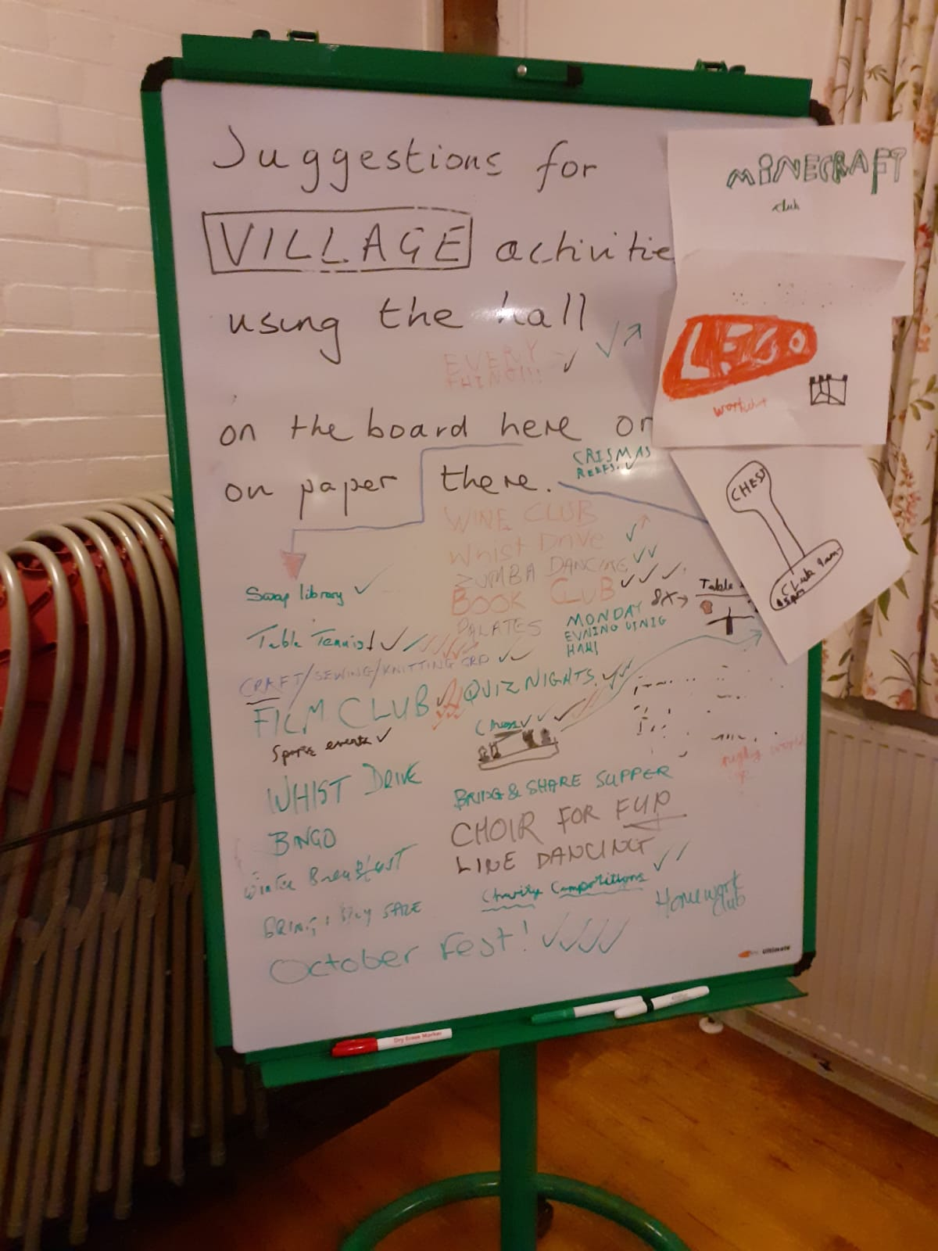Choir Workshop and evening Pilates classes and various supper ideas. For further news of events you can also check the Clyst St George Facebook page. If anyone wants to start up a group the first taster session arranged will incur no cost for the use of the Hall. We would love to see the Hall being used so much more, especially in the evenings. We look forward to hearing from anyone who can run a club or knows someone who wants to run a club and is looking for a space in which to do so. Villagers, this is our Hall, let us make it a lively centre for community events. Let’s build happy memories of times spent there just as Saturday evening was.

To give suggestions of taking ideas forward please email [pamela.difffey@btinternet.com](mailto:pamela.difffey@btinternet.com) and to enquire about availability of the Hall please email [claire.luxton69@btinternet.com](mailto:claire.luxton69@btinternet.com).

**Nature Garden**

Clyst St George has a delightful nature garden by the side of the parish church. The aim of the garden is to grow local Devon indigenous plants and trees and to encourage a Devon meadow with local wild flowers. Should you wish to help develop this ‘green’ facility, you can come along on the first Saturday of every month from 9.30 to 11 am.

**Clyst St George Church’s Stained Glass Windows**

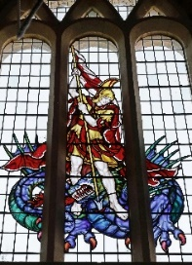These are stained glass windows from Clyst St George Church. The first window depicts the risen Christ found in the east window in the sanctuary above the high altar. The second depicts England's patron saint, St George and the Dragon found in the belfry window at the opposite end of the church. The glazier in each case was Hugh Easton (1906-1965), who in 1954 painted these dramatic images that cover all three windows (or lights) in the church. He was famous for designing the Battle of Britain window in Westminster Abbey, and can be identified by his weathervane motif in the left hand corner of both windows. They were donated by the Gibbs family as a memorial to Anthony Gibbs (d 1907), the patron of Clyst St George Church, and kindly photographed by William Finnigan.  Dr Stuart Bird

**Greetings Cards**

We are always grateful to receive cards (except Christmas ones) for remaking and they can be left in the church which is normally open between 9 am and 5 pm each day. Visitors will also find boxes of made up cards for sale covering birthdays, get well, sympathy, new home, thank you, anniversary, etc as well as

cards with no message or wording suitable for any occasion. Do call in and enjoy a few quiet moments browsing and perhaps buy a card. Linda Wilkerson (01392 875705)

**Little Dragons Pre-School**

We are pleased with the outcome of our Ofsted inspection in April 2018, where we were judged to be ‘good’. We still have a few spaces for children so do come and visit and meet our highly experienced staff team. We are based in Lady Seaward’s School and open four days a week, from Monday to Thursday 8.45 am ̶ 3.15 pm during school term times. For more information please telephone Elly on 07939 995486 (in school hours), email littledragons@live.com or visit our website [www.littledragonsclyststgeorge.com](http://www.littledragonsclyststgeorge.com).

~~~~~~~~~~~~~~~~~~~~~~~~~~~~~~~~~~~~~~~~~~~~~~~~~~~~~~~~~~~~~~~~~~~~~~~~~~~~~

**LETTERS TO THE EDITOR**

**The Wellingtonia in Clyst St George: What’s the Real Story?**

The following letter from James Muirden (grandparent of a pupil at Lady Seaward’s School) asks about the Wellingtonia in Clyst St George churchyard and why it was planted in 1863 by the Archbishop of Canterbury. This is the core of James’ letter:

*It seems probable that it was propagated by Veitch, the Exeter nurseryman who did so much to introduce new varieties into the country. He imported the first-ever batch of Californian Redwood seeds in 1853.*

*A Redwood can keep growing for thousands of years, and so (like all other examples in the UK) this 150-year-old specimen is still in its early adolescence. The seeds even from mature American trees have a very low germination rate, and therefore the chances of sprouting one from the Archbishop's tree were microscopic. However, to my delight, one of the several hundred I collected from cones last autumn has germinated, which seems almost miraculous!*

*So I wonder about the circumstances of its parent’s celebrated planting. What was the Archbishop doing in Devon and what local event was being marked by the baby tree?*

Lizzie Parkinson has been able to provide more detail:

*The plaque commemorates the planting by Archbishop Charles Longley on 3rd October 1863. With the introduction of many new tree and plant varieties at the time, it was the practice to commemorate a national event by planting specimens of these new varieties. The rector, Rev’d H T Ellacombe, himself a plantsman, though not as celebrated as his son Canon H Ellacombe, followed the fashion.*

*The tree was planted to commemorate the wedding of Queen Victoria’s eldest son, (later King Edward VII) to Princess Alexandra of Denmark. The wedding took place in March but why the tree planting in October? Archbishop Longley was a High Anglican churchman who did not approve of celebrations during Lent. However, the Queen, having been plunged into grief by the death of Prince Albert in December 1861, would not be moved. As Archbishop of Canterbury, Dr Longley had to bury his religious principles and officiate at the wedding. Rev’d Ellacombe was of the same mind as Dr Longley, so delayed his commemorative planting to outside Lent. Not all patriotic Devonians felt that way because the inhabitants of Colyton were very happy to erect a fountain in Lent to celebrate the national event.*