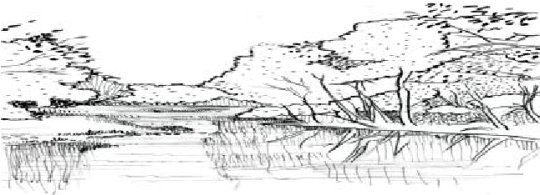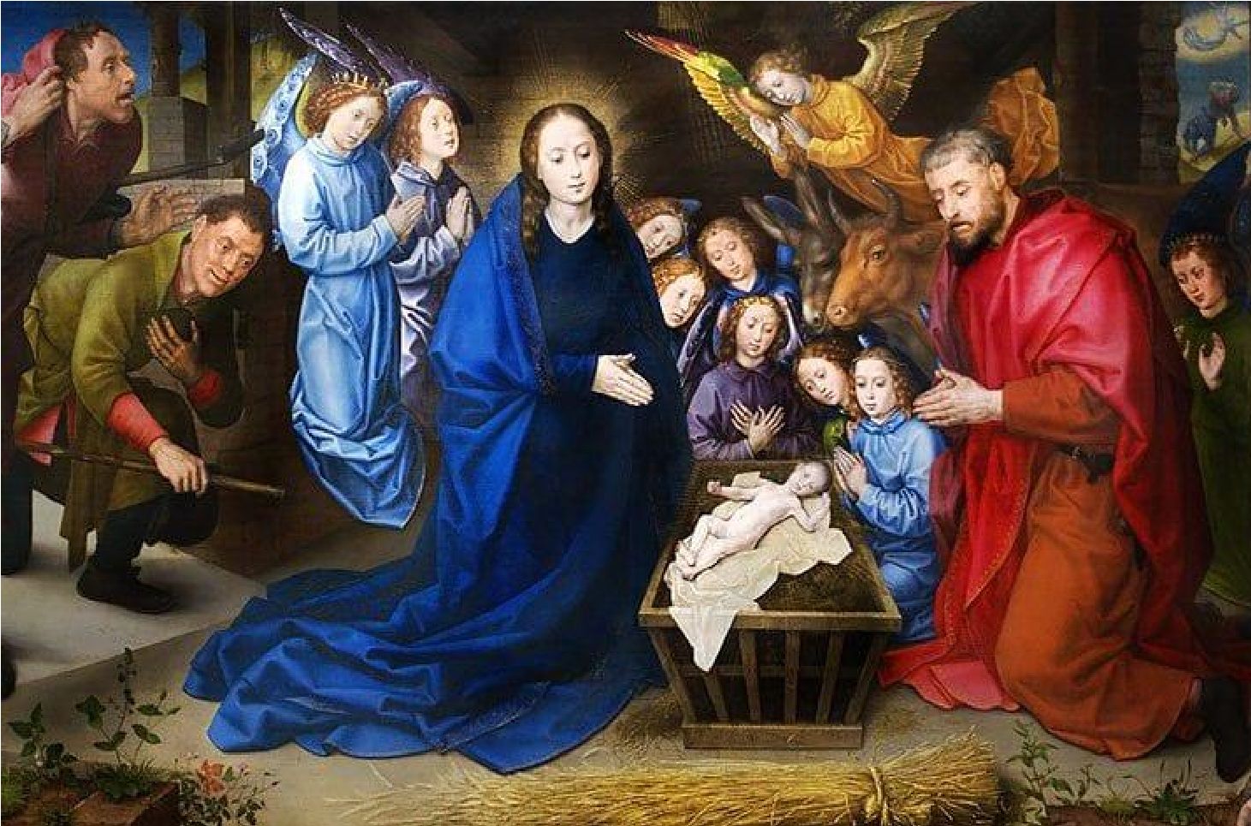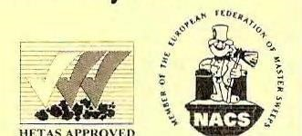

CLYST VALLEY NEWS

DEC
EM
BER

2021

CB Chimneys

For All Your Chimney
Needs

Clean & Efficient Service

Brush & Vacuum Sweep

Repairs & Maintenance
STEVEN CORNISH
Tel: 01395 268046

Mobile:
07970 892085

WOODBURY SALTERTON

VILLAGE HALL

Hall
–

Tables and chairs,

well equipped kitchen with cooker and
fridge, crockery and cutlery included in
hire.

Modest Rates

For bookings please contact:

Pat or Gill Bricknell

01395 232463

HANDYMAN SERVICE  - Odd jobs around the home  - Painting & Decorating  - Tiling & Flooring  Local, friendly and trusted  Call or message Sean  Tel: 0796 77 77 396 | 01395 233178 contact@marlowaccountants.co.uk www.marlowaccountants.co.uk  Friendly – Approachable – Affordable Family run with family values  UNIT 4 WOODBURY BUSINESS PARK WOODBURY EX5 1AY

Clyst St. Mary Village Hall

Recently refurbished with excellent
facilities

for meetings, parties, events, exhibitions,

trade shows etc. Large car park

and well
-
equipped kitchen.

Details of charges and
availability on

our new website

/
https://www.clyststmaryvillagehall.co.uk

or contact Ali West at:
-

bookings@c
lyststmaryvillagehall.co.uk

or on

01392 949088

Wills
|
Powers of Attorney
Probate
|
Trusts
|
Inheritance

Mike Dickson
Gardening

All Jobs Considered

Specialist in hedge cutting, shrub
pruning and grass

Mobile: 07985 697205

CHRISTMAS MESSAGE FROM THE VICARAGE

WHITE CROSS MISSION
COMMUNITY

Custom made
Curtains and Blinds
By

Rochelles

Free measuring service
Made on site in Exeter Showroom
1000
’s of fabrics to choose from

Fitting service
Interior styling service

Foam cut to size for boats/caravans
etc

Covers made for
your foam
130
Fore Street, Exeter. EX4 3JQ

01392 277921

k
www.rochellescurtains.co.u

enquiries@rochellescurtains.co.uk

I am indebted to a book called ‘Greener Grows the Grass’, by Christopher Tull (locally published, 2008) for this Christmas story, based upon a gospel passage; I paraphrase and shorten it below; to give a general message about friendship and present-giving – not to make any comment upon carol-singing; though I hope to be present at some of our outside singing events. I hope you enjoy it – it brought
a lump in my throat.
May you all have a blessed Advent, and a very special Christmas when it comes.
The chapter was called Friendship:
The curate didn’t approve of carol-singing round the houses in the parish – he saw it as a way of taking from the poor to those who were better off; he thought it should be the other way round. However, a new person in the parish wanted to organise it – he said people loved it. The vicar said ok, so one evening, the curate set off in a minibus (!) with some local families to the farthest ends of the rural parish. Down a lane he proposed to stop at a small cottage. ‘I wouldn’t go there,’ said one of the passengers, ‘they’d only put in a few pennies…not worth our while.’
But the driver persisted, stopped the bus and got out. Initially there appeared to be no light in the cottage, but as he got closer he could see a little light. He called the rest out and they could make out a couple huddled round a small fire and a single candle for light. It was two days before Christmas, but there were no decorations and just a solitary card on a table. After the carollers sang ‘Silent Night’ they knocked on the door; after a period of time and shuffling, the old lady came to the door – with two little coins, with tears in her eyes. She said something like this: ‘It’s the first time us as ever ‘eard they singers for fifty years or more. ‘Tis like Christmas when we were young...’ Her husband joined her in the doorway as they sang ‘Away in a Manger’.
Afterwards, over mince pies in the vicarage this story was retold. It just so happened that one of the group recycled Christmas cards, properly, and sold them for the church – so there was a ready supply. There and then each decided to write a card and the following day the vicar pushed a big bundle through the cottage’s letterbox.
It proved to be the couple’s last Christmas; they were threatened with being moved into a home. Both happened to die, separately, early in the New Year. Later, the vicar was called out to help with clearing the house. Amongst their meagre belongings, he found an old wooden screen decorated with Christmas cards which he instantly recognised. There was a note pinned to the top of the screen on which were written these words: ‘A present from our friends’.
Bill and Daff Lemmey, Woodbury Vicarage revbillwhitecross@gmail.com 01395 232161
~~~~~~~~~~~~~~~~~~~~~~~~~~~~~~~~~~~~~~~~~~~~~~~~~~~~~~~~~~~~~~~~

WHITE CROSS MISSION COMMUNITY

Churches Open!
We are delighted that all seven churches in the WCMC continue to be fully open! For details of the scheduled services for Advent and the Christmas period, please see the programme at the end of the magazine.

~~~~~~~~~~~~~~~~~~~~~~~~~~~~~~~~~~~~~~~~~~~~~~~~~~~~~~~~~~~~~~~~

Contributions, photos and letters to the editor for the January 2022 issue of the Clyst Valley News should be sent by email, to the editor, Peter Skelton, at clystvalleynews@gmail.com by Wednesday 8th December 2021 at the latest, please. Please note that contributions may be edited.
If you experience any difficulty in receiving your copy of the CVN, please contact your local distributor, as follows:
CSG & Ebford Isobel Stubbs 07826 806919
CSM Ivor Spriggs 01392 874382
WS Debbie Jung 01395 232328
~~~~~~~~~~~~~~~~~~~~~~~~~~~~~~~~~~~~~~~~~~~~~~~~~~~~~~~~~~~~~~~~

EDITOR’S NOTE
Hello and welcome to this festive December edition of the Clyst Valley News. As I write, we’re experiencing that delicious bright, crisp, late autumn sunshine which is such an uplifting contrast to the very heavy rain we had earlier. I’m actually really enjoying digging out those thick woollies and warm scarves.
I thought you might like to know that our cover picture is of Hugo van der Goes’s ‘Adoration of the Shepherds’, painted in oil around 1480. It currently lives in the Gemäldegalerie in the Staatliche Museen zu Berlin in Germany. Magnificent! (I particularly like the faces of the two shepherds looking in from the left.)
As we begin to gear up for the Yuletide season, which looms rather ominously only a month away now, I’d like to pay tribute to one of our most stalwart supporters who has been coordinating the distribution of our magazine in Clyst St George and Ebford for many, many years; and who has decided it’s time to hang up her delivery bag. Lizzie Parkinson has been an absolute rock and a beacon of reliability, come rain or shine. And, as with all our deliverers, it’s all been voluntary, for which we are all extremely grateful. So, from me and on behalf of our readers, a huge thank you to Lizzie for all that she has done for the CVN; and a warm welcome to Isobel Stubbs who has kindly agreed to take over her distribution responsibilities.
I’m very pleased to be able to tell you that we’ve had an early, and very welcome, Christmas present from Burrington Estates, who have just renewed their generous sponsorship of the CVN for another year. We are most grateful; this will enable us to move forward with confidence through to early 2023 at least.
It just remains for me to wish all of our readers and supporters a very Happy Christmas. Stay well and see you next year! Do try our Christmas Quiz! Best wishes. Peter Skelton
~~~~~~~~~~~~~~~~~~~~~~~~~~~~~~~~~~~~~~~~~~~~~~~~~~~~~~~~~~~~~~~~
WHY NOT ADVERTISE IN THE CLYST VALLEY NEWS?
If you are interested in advertising your business or organisation in the Clyst Valley News in 2022, please get in touch - with no obligation. Contact the Editor, Peter Skelton, at clystvalleynews@gmail.com or on 01392 879857 without delay!
~~~~~~~~~~~~~~~~~~~~~~~~~~~~~~~~~~~~~~~~~~~~~~~~~~~~~~~~~~~~~~~~ YOUR PHOTOS ALWAYS NEEDED FOR THE COVER OF THE CVN!
There must be a lot of photographers out there snapping away around our villages. After all, our neck of the woods is rather photogenic. Why not share your results with our readers? Most months we aim to put one nice pic on the magazine cover and we need yours! So please do send in your efforts to the editor, Peter Skelton, who will choose one each month. Try to use relatively highdefinition settings but that’s not a must. Just email them across to clystvalleynews@gmail.com and we’ll do the rest. Simples!
~~~~~~~~~~~~~~~~~~~~~~~~~~~~~~~~~~~~~~~~~~~~~~~~~~~~~~~~~~~~~~~~ SUBSCRIBE TO THE CLYST VALLEY NEWS NOW! IT’S COMPLETELY FREE!
If you’d like to receive your own copy of the CVN (in full colour!) direct to your email address every month, completely free of charge, all you have to do is email the Editor, Peter Skelton, at clystvalleynews@gmail.com with the following message: ‘I am happy to receive the Clyst Valley News at this email address once a month. I understand that the CVN will not pass on my email address to any third party without my written permission.’ Please do sign up! You can cancel at any time. Thank you.
~~~~~~~~~~~~~~~~~~~~~~~~~~~~~~~~~~~~~~~~~~~~~~~~~~~~~~~~~~~~~~~ THANK YOU AND WELCOME!
After many years distributing the Clyst Valley News in Clyst St George and Ebford, Lizzie Parkinson is handing over the baton to a newcomer to the village, Isobel Stubbs, also a new member of the Parish Council. We both send our heartfelt thanks past and future to all those who help in the magazine distribution and may Isobel enjoy the task as much as I have. Thank you, Isobel! Lizzie Parkinson

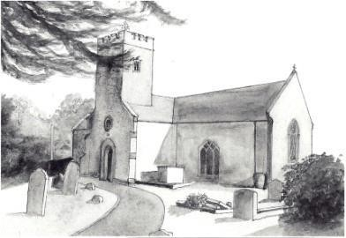
~~~~~~~~~~~~~~~~~~~~~~~~~~~~~~~~~~~~~~~~~~~~~~~~~~~~~~~~~~ CLYST ST MARY Clyst St Mary Church Services in December
The Family Service with Breakfast will be held on 5th December, starting at 9.30 am. This is a very informal gathering for parents and children, lasting no more than an hour (including breakfast!) so that you have the rest of the day for other family activities. There will be a Family Communion Service on 19th December, at 9.30 am as usual. We welcome new families who would like to bring their
children to join us in these services. There will be a Christingle Service at 3 pm on Christmas Eve. The Carol Service will be held on Friday 17th December at 6.30 pm. All are welcome to this festival of lessons and carols to get into the true spirit of Christmas. Mulled wine and mince pies will be served after the service.

Christmas Bazaar
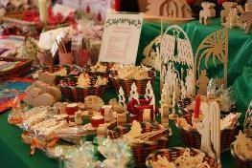
On Saturday 4th December our coffee morning will be a Christmas Bazaar from 10 to 11.30 am in church. We will be having refreshments, stalls and hopefully you will find a little something to add to your Christmas buying. All proceeds to the church and everyone welcome, as always. Please come along and join us for coffee and a chat.

Christmas Concert
There will be a Christmas Concert in church on Monday 6th December, starting at 7.30 pm. This will be a festive concert with music from St David’s Singers and readings to celebrate the Christmas season. Refreshments will be served in the interval. Tickets are £6.00 payable on the door. To reserve a seat call Rob on 01392 874305.
Christmas Flower Arrangement.
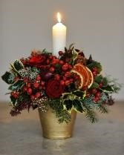
On Wednesday 8th December from 2 pm we are holding a new event in the church. Margaret Stainfield, judge of flower arranging and all things arts and crafts, has kindly agreed to show us how to achieve a simple but effective Christmas arrangement. But you will be doing this alongside Margaret and you can take it home with pride and have it ready for Christmas. Please look out for social media and flyers to find out what you will need to bring with you. Don’t worry if you cannot find everything, because I am sure we can help on the day. Afternoon refreshments including cake etc. will be there to help with your inspiration!! Thank you and do so hope you can come along and relax for a couple of hours before the rush of
Christmas. Best wishes. Pat Cusa, Churchwarden and Margaret Stainfield

Church Cleaning
Now that the church is open again, we are looking for volunteers to help with cleaning. It would involve about two hours of your time about every two months. If you feel you could help in this way, please contact Don Axford on 01392 873615.

Coppers!
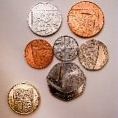
Shopping online means that there is not a lot of small change about but if you do have any that is weighing your pockets or purses down, it will be gratefully received in support of church funds. Either leave it in church at a service or with me, Don Axford, at 34 Frog Lane. Although I am no longer Church Treasurer, I am still willing to collect your loose change. If you find it difficult to deliver, I will collect, obeying social distancing rules, etc, if you ring me on 01392 873615.

Bishops Clyst Parish Council Greenspire to Clyst St Mary Village Footpath. We are pleased to report planning consent has been granted for the footpath from the Greenspire Estate to the village and we are now able to proceed with arranging construction. Parish Council Vacancies – Environmental Champion Required! There are still vacancies for Parish Councillors on the Bishops Clyst Parish Council. If you would like to represent the residents of Clyst St Mary and Sowton Village on the Parish

Send in your ideas for celebrating the
Bank Holiday, 2
^{nd}

–

5
^{th}

June 2022

bishopsclyst@gmail.com

Council we would very much like to hear from you. We
are particularly keen to recruit someone with an interest in the environment to be our Climate Change/Green Champion. If this appeals to you, or you have other areas of interest, please email our Clerk, Karan Bennett, at bishopsclyst@gmail.com with a personal statement setting out what skills and experience you would bring to the Council.
Parish Council Meetings. Parish Council meetings take place each month and dates, agendas and minutes are posted on our website (http://www.bishopsclyst.org.uk) and on noticeboards in Clyst St Mary and Sowton Village.
Christmas Greetings. We would like to wish our residents a very Happy Christmas and best wishes for 2022!
Contact the Parish Council. Karan Bennett, PC Clerk, working from the PC office in Clyst St Mary Village Hall on Monday to Wednesday, 9 am to 1 pm. Call 01392 874405 or email bishopsclyst@gmail.com.

Clyst St Mary Primary School
November was a busy month, and the Year 6 footballers were particularly excited by the return of the Exeter
Primary Football League. A two-minute
silence was held at 11 am on 11th November to mark Remembrance Day and show our respect to those who have given their lives to protect us all. Funds were raised for the British Legion with the sale of traditional poppies, decorated rubbers and reflective poppies. We also fundraised for Children in Need with a Wear Your Own Clothes Day around the theme of ‘Feel Good Friday’. It was lovely to see the children in all their bright colours. As the month ended the PTFA held a Christmas Fayre in school on the 27th - maybe some of you visited and bought a few Christmas presents!
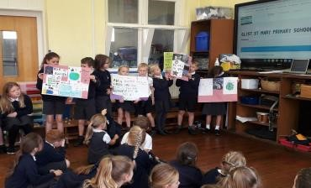
In this second half term we have started to work on a British Council project with a school in Tanzania. The children have really enjoyed participating in video links with the Tanzanian children - thank you to Mrs Rose for her support with this project and helping us learn a few words of Swahili. Both schools are going to come up with and share targets and progress for reducing the use of plastics, particularly single use plastics, in our schools. The project is also supported by Surfers Against Sewage.
Christmas celebrations have begun in earnest and weather permitting we will be holding our
Christingle Service in the school playground on 2nd December. If conditions let us down, we will have another go on 8th December. We are really missing using our beautiful village church which creates such a wonderful atmosphere for this Christmas celebration but sadly it is just too small for us all to gather safely - fingers crossed for next year.
The younger children will be performing their Nativity, A Magical Christmas Journey, in the Village Hall on 15th December, this year with an audience!
We wish you all a very Merry Christmas and a Happy New Year.

Clyst St Mary Village Hall
It’s a great pleasure to see that the bookings for the Village Hall are again building as hirers find that they are able to operate within the guidelines particularly given that the
Hall is spacious and can be well ventilated. Our new website https://www.clyststmaryvillagehall.co.uk/ gives
details of availability and prices but if there’s anything else you’d like to know, please drop Ali
West an email on: bookings@clyststmaryvillagehall.co.uk. We look forward to seeing you soon.

Table Tennis Club
Please come and join us! We resumed play at the Clyst St Mary Table Tennis Club in
May. New members always welcome. We play at the Village Hall every Thursday, 4-
6 pm. The minimal fee of £20 for a 10-week session includes use of all equipment
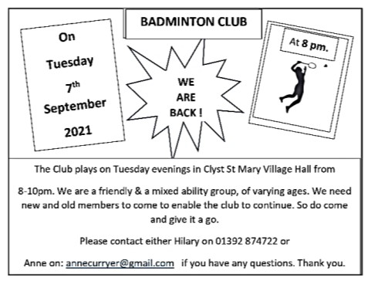
and refreshments. For further details please contact Pam Gardner on 07714 097220 or by email to pamelamgardner9@gmail.com.

Clyst Valley Pre-School
Clyst Valley Preschool has remained open throughout the pandemic for all our children and is now full at almost every session. We are currently taking applications for September 2021 and beyond with sessions available on every day. Sadly we are not yet able to hold open days or taster sessions but hopefully this will change as lockdown is eased and things return to a new normal! To apply, or for more information, check our website www.clystvalleypreschool.org. You can also call us on 01392 876615 or email us on manager@clystvalleypreschool.org.
~~~~~~~~~~~~~~~~~~~~~~~~~~~~~~~~~~~~~~~~~~~~~~~~~~~~~~~~~~~~~~~~

CLYST ST GEORGE AND EBFORD
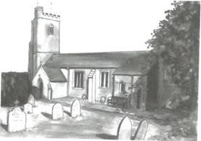

CSG Parish Council Chairman’s Notes, December 2021
The Council are pleased to launch a text alert system, run by the Government so that local councils can keep you informed and safe. We had to jump through a number of hoops to set this up, including registering with the Information Commissions Office
(ICO) and we will only store your mobile ‘phone number. To join
please email your number to our Clerk at clyststgeorgeparishcouncil@googlemail.com. The alert texts will be sent out to update you when the power is off; also if anything that affects a number of people and could be either dangerous or highly inconvenient. So it’s to keep the public informed.
The Council were sad to hear of Roger Horner’s passing. He served this community both as Chairman of the Hall and as a Parish Councillor, for many years. We have sent our condolences to Barbara and family. Stay safe. All the best.
John Manser john@jmanser.co.uk 01392 874861

Norman’s Weather Report for September
October’s total rainfall of 169 mm (6.6 inches) was exceptionally high, comparable to that of the very wet May of this year. Particular October features were 124 mm over the last two weeks, which were preceded by 13 dry days between the 6th and the 18th, during
which your correspondent was able to celebrate his birthday!
The 20-year average for the month here at Ebford is 96.5 mm or 3.8 inches; wide variations have of course occurred between one and 7½ inches. Norman Cann

Lady Seaward’s C 0f E Primary School
Class One – Alps. We have had a super start to the half term. Children are showing us their best behaviour and learning attitudes. We have been thinking about celebrations in the last few weeks. We looked at Remembrance Day, Bonfire Night
and Diwali, to name a few. Below are examples of the work that the children have produced!
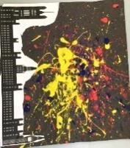
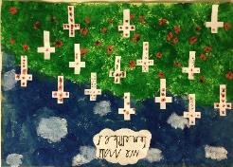
Children in Need Appeal A big thank you to all of the Lady Seaward’s Primary School community for a fantastic fundraising effort for Children in Need. We raised a whopping £335.68!
We are looking forward to the festive season and are busy getting ready for our Christingle Service later this term.

Clyst St George Parish Hall
Clyst St George Parish Hall is open once more to anyone who wants to hire the Hall. We are not making the Ethel Cann Room available at the moment as it is too small to adhere to the social distancing rules. The Hall has been redecorated and
is looking splendid.
There are hand sanitising units at strategic points in the building for the use of the hirers and hirers are asked to be responsible for making sure that they adhere to the government guidelines for holding gatherings in a COVID-safe way. Our cleaner will use PPE when working in the Hall and he has special cleaning fluids to make the area as safe as possible. We are confident we will resume the coffee mornings (see above), Big Breakfast and the quiz evenings, hopefully soon. Watch this space! Enquiries to Claire Marks at clyststgeorgeandebfordvhall@outlook.com or ‘phone 07834
234546. Pamela Diffey (Chairperson) 01392 877497

Nature Garden
Clyst St George has a delightful nature garden by the side of the parish church. The aim of the garden is to grow local Devon indigenous plants and trees and to encourage a Devon meadow with local wild flowers. Should you wish to help develop this ‘green’ facility, you can come along on the first Saturday of every month from 9.30 to 11 am. (PLEASE CHECK IN ADVANCE.)

Little Dragons Pre-School
We are pleased with the outcome of our Ofsted inspection in April 2018, where we were judged to be ‘good’. We have now re-opened and have been operating at full capacity from September. We are based in Lady Seaward’s School and open four days a week, from Monday to Thursday 8.45 am ̶ 3.15 pm during school term times.
For more information please telephone Elly on 07939 995486 (in school hours), email littledragons@live.com or visit our website www.littledragonsclyststgeorge.com.
~~~~~~~~~~~~~~~~~~~~~~~~~~~~~~~~~~~~~~~~~~~~~~~~~~~~~~~~~~~~~~~~
WOODBURY SALTERTON

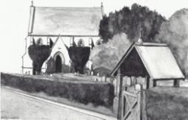
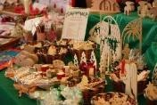
Christmas Events
Church Christmas Bazaar. This will be held in the Village Hall from 10 am till noon on Saturday 4th December.
Festive Windows. Please decorate one of your windows with some Christmas
cheer to brighten up the village and raise some money for the church.
The cost to enter is £5 and there will be a £10 prize for the best entry. Entry forms from Debbie Jung. If possible get your entry up by 6th December but later entries will still be gratefully accepted.
Church Carol Service. Following the success of last year’s outdoor event, the carol service will take place at 4 pm on Sunday 19th December in the churchyard. Should it rain we would adjourn inside the church.
Midnight Mass will start on Christmas Eve at 11.30 pm and we are delighted that Rev’d Nigel Mason will be coming back to take this. Carol Singing Round the Village. Wednesday 22nd December. Please
meet outside The Digger’s at 6 pm Everyone welcome – and you are welcome to bring your dog! As usual
we will be collecting for The Children’s Society.

Remembrance Sunday
The annual Act of Remembrance on Remembrance Sunday took place at the church lych gate. It was conducted by Graham Gerdes and William Olney played The Last Post and Reveille on his trumpet. Patrick Bricknell laid the poppy wreath. A short service followed outside the lych gate led by Debbie Jung (Churchwarden) and church choir members led the singing of the hymns with keyboard accompaniment. Just over 40 people attended. It was generally agreed that the music added greatly to the solemnity of the occasion. Special thanks to William.

Beetle Drive.
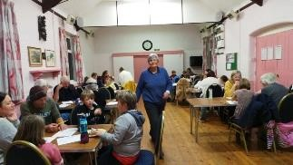
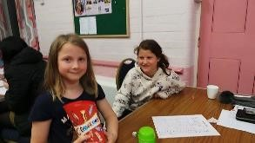
The Village Hall rang with laughter and chatter on Saturday 13th November as a Church Beetle Drive was held there. It was the first major fund-raising event for the church to take place in the Hall since before the pandemic and for many the first time they had been into the Village Hall since March
2020 apart from going there to vote. It
was good to see lots of young families enjoying the fun. Debbie Jung organised the event and was MC. The top scorer and winner of the prize was Panka, one of our new choristers (pictured with her prize; and her sister, Luca, who has also joined our choir). The evening raised £143 for church funds.

To All Those Residents of the Parish of Woodbury Salterton Who Will be 70 and Older by Christmas 2021
The Kerslake Trust
This Trust was created on the death of Celia Elizabeth Kerslake on 19th September 1939. Under the terms of her will, some shares were left to the Trustees of Woodbury Salterton Church, with the instruction that the income received from them should be distributed among ‘the old people over 70 belonging to the Parish at Christmas time’.
The Trustees are currently reviewing the list of beneficiaries to arrange this year’s distribution and will be pleased to hear from anyone permanently resident in the Parish who has NOT received a payment in previous years and who considers they now qualify for such a payment.
Last year 44 people benefitted from the Kerslake Trust and many very kindly donated their gift back to the church. If you would also like to have your share of the distribution paid straight into the church funds, please let the Trustees know.
Please advise Nigel Dupain, Trustee, on dupain@hotmail.co.uk or by ‘phone on 01395 232953 by 15th December 2021.
~~~~~~~~~~~~~~~~~~~~~~~~~~~~~~~~~~~~~~~~~~~~~~~~~~~~~~~~~~~~~~~~~~~

POETRY CORNER

Magic Box
by John Smith (of Clyst St Mary)

Mum said, ‘What do you hope
That Santa will bring you this year?’
(We play this game of believing Although I have no fear Of the truth).

I’ve seen a really good programme
Where a man does magic tricks
I’d like to amaze my friends And change cards with a flick Of my finger.

So I said that’s what I hoped for
A box to work some fun
And be the star of the show- But I know that magic’s done In the mind.

When special people are with me
It happens all the time,
A tightness in my chest That says to me that I’m Special to them.
©John Smith
~~~~~~~~~~~~~~~~~~~~~~~~~~~~~~~~~~~~~~~~~~~~~~~~~~~~~~~~~~~~~~~~~~~
AND FINALLY…

The Exeter Forum Talks Programme: 1st December 2021 to 5th January 2022
The Exeter Forum weekly talks programme summary from 1st December to
5th January appears below. More detailed descriptions of talks and
speakers will feature in the weekly newsletter. Talks take place on Wednesdays at the Mint Methodist Church in Fore Street, Exeter. Members assemble for meetings from 10.15 am. After time for coffee and socialising, the talk starts, usually at around 10.45 am.
Date Speaker Title
1st December Tony Davis How Did the Kings Find Bethlehem?
In this seasonal talk, Tony will examine the story that the Kings arrived in Bethlehem by following a star. He will describe how navigation has evolved over the centuries and consider possible solutions to the Kings’ problem.
8th December Tracey Norman Cards, Cocoa and Charms - Devon's Forgotten Witches Tracey’s talk will examine some fascinating and almost entirely unknown cases involving witchcraft in Devon.
15th December Christmas Event (details to be confirmed)
22nd December No meeting
29th December No meeting
5th January Mark Norman Beyond the Hound of the Baskervilles
This talk explores the folklore surrounding the phenomenon of sightings of phantom black dogs in the UK, their long history and folklore, and how they inspired Sir Arthur Conan Doyle to write 'The Hound of the Baskervilles'.

Exmouth Mobile Library Timetable 2021
Day | Village | Stop | Arrive
Friday | Aylesbeare | Nightjar Inn | 09.50
Friday | Clyst St Mary | Cat and Fiddle | 12.10
Tuesday | Clyst St Mary | Winslade Park | 14.50
Tuesday | Clyst St George | School | 15.20
Monday | Exton | Station | 09.45
Friday | Woodbury Salterton | Kennels | 12.50
Christmas Trivia Quiz [Answers after Festive Funnies.]
- – If you’re born on Christmas Day, what’s your star sign?
- – What colour are mistletoe berries?
- – Which animal carried Mary before she gave birth to Jesus?
- – In which year was the first Christmas card sent – 1743, 1843 or 1943?
- – Which ocean can Christmas Island be found in?
- – Where was baby Jesus born?
- – Which one of Santa’s reindeer has the same name as the god of love?
- – How do you say ‘Merry Christmas’ in Spanish?
- – What was Frosty the Snowman’s nose made out of?
- – Which horned figure is said to punish naughty children at Christmastime?
- – What’s the name of the period leading up to Christmas?
- – Which Angel visited Mary?
- – On which date is Christmas celebrated every year?
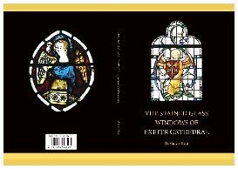
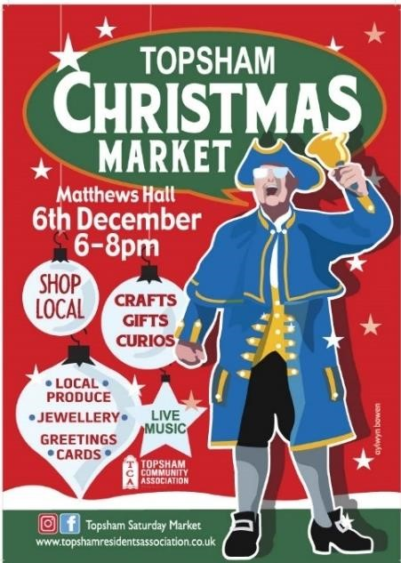
- – What red-breasted bird do we commonly associate with Christmas?
Woodbury

Woodbury

White Hart

14.00

Dates for Friday stops: 10
th

December; Tuesday

7
th

December
.

Disclaimer: Due to operational circumstances, the mobile library may need to
be off road and unable to visit on
some dates.
Details will be publicised
closer to the
time. These
timetables
may
be
subject
to
change.

- – 26th December marks which Saint’s Day?
- – What is Scrooge’s first name?
- – Which plant, beginning with p, is associated with Christmas?
- – When Santa got stuck up the chimney, what did he have in his sack?
- – What gifts did the Three Wise Men give to Jesus on his birthday?
- – What is the name for the shortest day of the year?
- – What does Santa give to naughty children?
- – Which famous scientist was born on Christmas Day in 1642?
- – Which pantomime does Buttons appear in?
- – How do you say ‘Merry Christmas’ in Welsh?
- – Which one of Santa’s reindeer has the same name as a fox?

New Exeter Cathedral Stained Glass Book
‘Stained and painted glass has for over a thousand years transformed the light and atmosphere which enters religious buildings in this country and throughout the continent. It has effectively put colour to the Bible and our well-known Gospel stories. The early years saw this as a way of teaching the Bible to those less well versed, as well as edifying the Church to the glory of God. This in turn gives a real appreciation of the works and skills of the craftsmen and women down the ages who created these beautiful works of art.
‘Exeter Cathedral has a great historical collection of stained and painted glass, much documented in the Cathedral Archives. Up until now there has been no overall guide to this wonderful collection of stained and painted glass, readily accessible to worshippers and visitors. Examples are glass dating from the 14th century in the Great East Window, by Maste r Walter and Robert Lyen through to the mid-18th century enamel painted glass by William Peckitt of York, now in the cloisters, and then the highly decorated mid-19th century Victorian glass, up to the post-war period and beyond, all reflecting the fashion and age in which they were created.
This has now been brought together in a wonderful guide which will help visitors and all those with a keen interest in stained glass to look, appreciate, and understand this collection of glass. ‘I wholeheartedly commend this guide, carefully put together by Dr Stuart Bird [of Ebford], and beautifully illustrated with William Finnigan’s photography, to all who enter Exeter Cathedral, whether to worship and pray, or simply admire the skills and craftsmanship of stained glass throughout the building. All will no doubt be greatly inspired.’ (Rev’d Andrew Johnson, Master Glazier AMGP)
The guide costs £5 (to include a guided trip around the Cathedral if you wish), obtainable from the Cathedral shop or directly from Stuart at stuart.r.a.bird@gmail.com. The profits will go to Cathedral funds.

’Tis the Season - and Topsham’s the Place
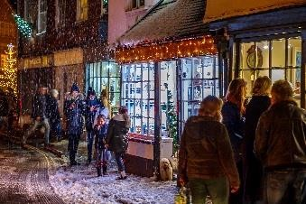
There are two reasons to come to Topsham this month - the first is to get to the heart of Christmas with festive fun and retail therapy; and the other is to have the perfect antidote to Christmas with
strolls and views away from the madding crowd. Let’s start with the obvious - if you want to shop or enjoy indulgences this season, there is no better place to visit than
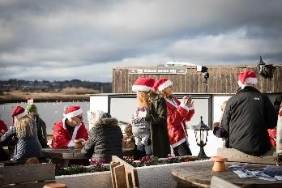
Topsham. We’ll have a special Christmas Trail for our young residents and accompanying grown-ups from 3.15 pm on 8th December when you can pick up a route map and swag bag from our elves at Matthews Hall. They will send you to 18 locations throughout the town where there will be treats galore from local cafés and shops, culminating in a very special display arranged by Topsham Museum. All you need to know about this is on our lovetopsham.co.uk website. And if you want to buy - well, where do we start? There are over 50 independent shops with perfect gifts from dog beds to handmade soap, farm-fresh
turkeys to artisan crafts. Yes, many of them have gift vouchers too, so please just check our website for details.
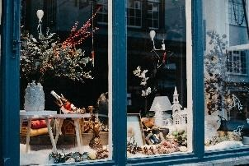
You know already that when you’ve dropped after that shop, there’s no shortage of cafés, bars and restaurants to rest your feet and enjoy that mulled wine (or craft gin, or barista-made coffee, or…).
If you’re after a little exercise there are walks. For those wanting a little more Christmas, try a tour of the shopfronts in the town and see if you agree with the judges’ decision in our annual Best Dressed Shops Competition - look out for the certificates in the successful stores! Along the way you’ll see LoveTopsham’s Christmas lights and trees across our main shopping areas - we’re biased, of course, but we think the town has never looked more magical.
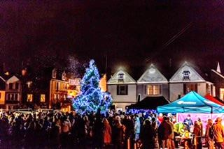
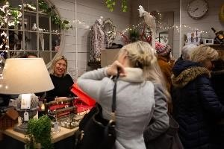
If that’s not enough, try a stroll through the matrix of Topsham’s quaint streets to see what we can promise you will be a fantastic selection of lights and decorations on many of the homes too. However, if you want a complete break from the hustle and bustle of the season - there’s something for you too.
If you haven’t been to the glorious Goat
Walk, seen the RSPB Hide at Bowling Green Marsh, or simply sat in silence at Topsham Quay, perhaps this month is the time to enjoy
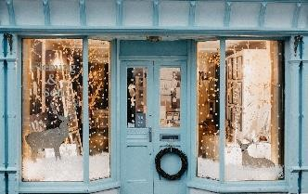
peace and relaxation away from the crowds. Whatever you wish for this Christmas, Topsham may well be the place to find it. We hope to see you in the town this month; whatever you come for, all that remains is for us to thank you for your support in 2021, to wish you a loving and peaceful festive time, and to have a healthy New Year. Jingles from the Love Topsham team.

Estuary League of Friends
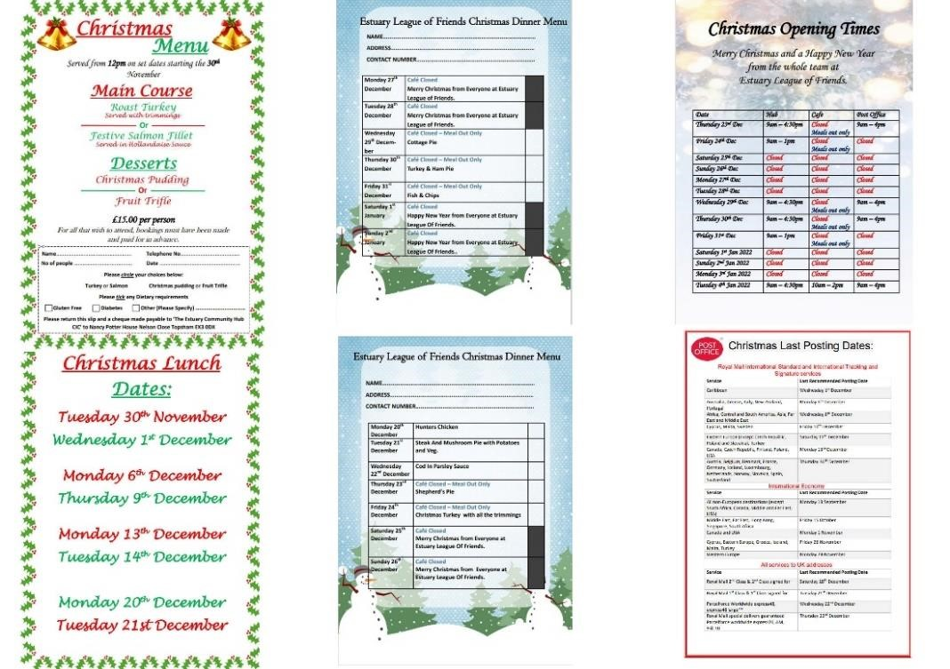
Working to improve the quality of life of those in need of care, comfort and support

in our community since 1987
.

Festive Funnies
Father: Did you see Father Christmas this year, son?
Son: No, it was too dark to see him but I heard what he said when he stubbed his toes on the edge of my bed.

A four year-old boy was asked to give the meal blessing before Christmas dinner. The family members bowed their heads in expectation. He began his prayer, thanking God for all his friends, naming them one by one. Then he thanked God for Mummy, Daddy, brother, sister, Grandma, Grandpa, and all his aunts and uncles. Then he began to thank God for the food. He gave thanks for the turkey, the stuffing, the Christmas pud, the mince pies, the cakes, even the brandy butter.
Then he paused, and everyone waited-- and waited. After a long silence, the young fellow looked up at his mother and asked, ‘If I thank God for the Brussels sprouts, won't he know that I'm lying?’

I don't care who you are, get these reindeer off my roof!

Mum, can I please have a dog for Christmas?
No, you will have turkey like everyone else!

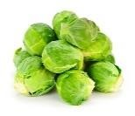
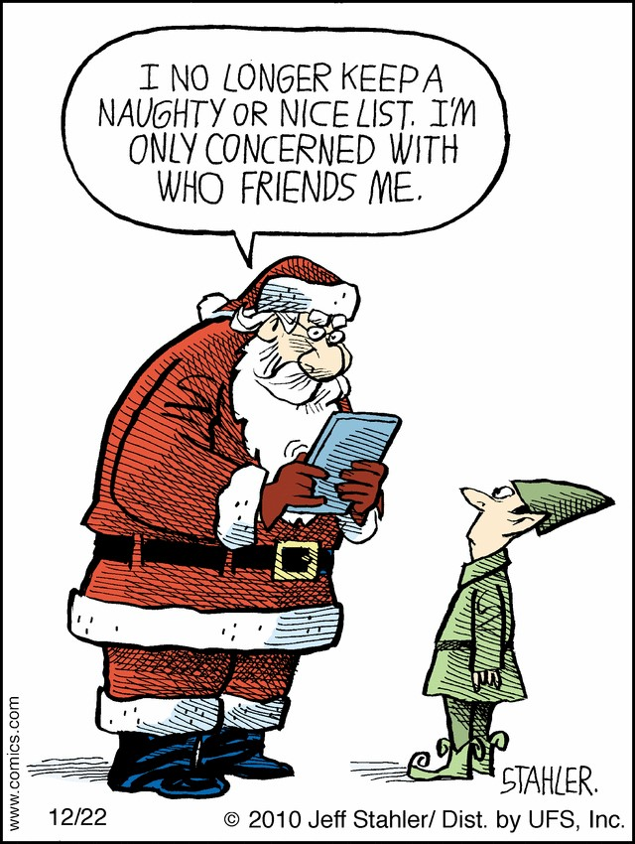
It was Christmas Eve. After putting her grandchildren to bed, a grandmother changed into her old clothes and proceeded to wash her hair. She heard the children getting very excited in the bedroom so finally she threw a towel round her head and stormed in to their room, putting them back to bed with a stern warning that if they didn’t go to sleep, Santa wouldn’t come. As she left the room she heard the three year-old say, with a trembling voice, ‘Who was that?’
[Thanks to Lesley Richardson. Slightly amended! Ed]

Darth Vader and Luke Skywalker were having one of their little father and son chats...lightsabres drawn and sparks flying. Vader pinned Luke against a bulkhead and glared
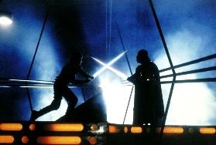
into his face. ‘I know what you're getting for Christmas, Luke,’ he said, ‘ohhh, yes! I know!’
Luke fought himself free and jumped to a higher platform just out of Vader's reach. ‘How do you know!?’ Luke yelled at him. ‘How do you know what I'm getting for Christmas!?’
Darth Vader shot Luke an icy glare. ‘The force is with me...I felt your presents.’
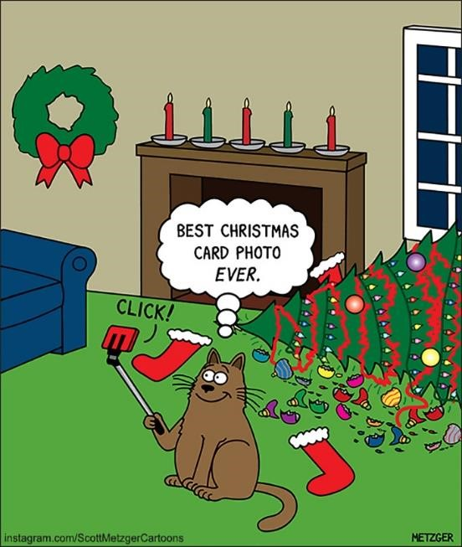
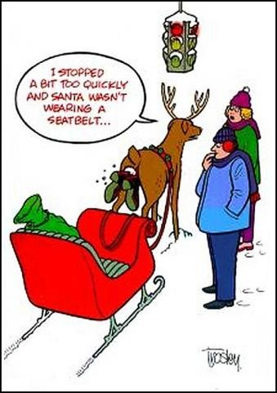
Ladies, don’t forget the Christmas jumble sale. It’s a chance to get rid of those things not worth keeping around the house. Bring your husbands.
[Thanks to David Palmer. Also slightly amended! Ed]

There was once a great Czar in Russia named Rudolph the Red. He stood looking out the windows of his palace one day while his wife, the Czarina Katerina, sat nearby knitting. He turned to her and said, ‘Look my dear, it has begun to rain!’
Without even looking up from her knitting, she replied, ‘It's too cold to rain. It must be
sleeting.’
The Czar shook his head and said, I am
the Czar of all the Russias and Rudolph the Red knows rain, dear!’ [Sorry! Ed]

Politics is the art of making it sound as if Father Christmas comes earlier in the year.

Two guys walked deep into a forest searching for a
Christmas tree. After spending hours in the deep snow and biting wind, one guy turned to the other and said, ‘I'm going to chop down the next tree I see. I don't care whether it's decorated or not!’

What did Adam say on 24th December? It's Christmas, Eve.
Answers to the Christmas Trivia Quiz
1. Capricorn 2. White 3. Donkey 4. 1843 5. Indian Ocean 6. Bethlehem 7. Cupid
8. Feliz Navidad 9. Button 10. Krampus 11. Advent 12. Gabriel 13. 25th December 14. Robin
15. St Stephen 16. Ebenezer 17. Poinsettia 18. Soot 19. Gold, frankincense & myrrh
20. Winter solstice 21. Coal 22. Isaac Newton 23. Cinderella 24. Nadoleg Llawen 25. Vixen

RDC LANDSCAPING

07916 814304

rdclandscapers@gmail.com

FENCING

PATIO SLABS

ARTIFICIAL GRASS

TURF
Please call for a no-obligation quote
.’

WCMC SERVICES DECEMBER 2021
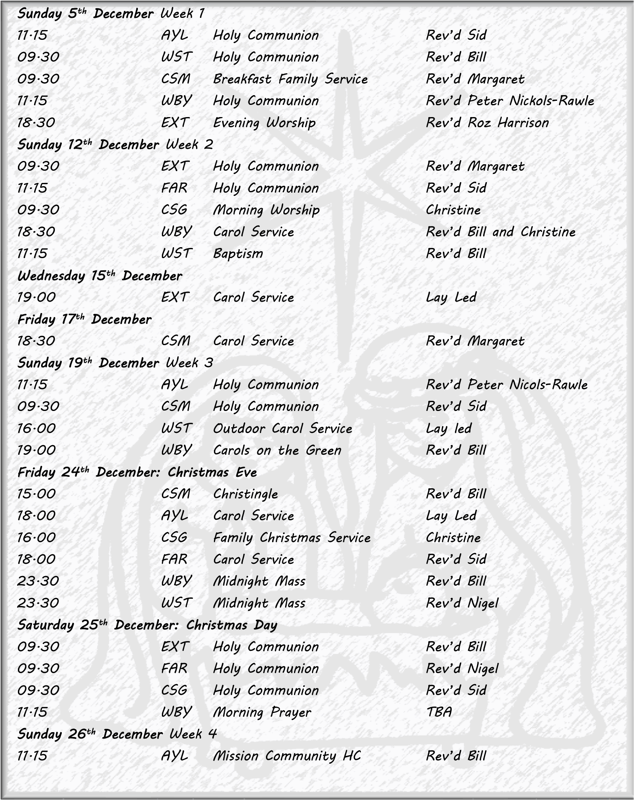

AYL Aylesbeare FAR Farringdon EXT Exton WST Woodbury Salterton WBY Woodbury
CSG Clyst St George CSM Clyst St Mary

