CLYST ST GEORGE PARISH COUNCIL
RE: Clyst St George Annual CIL Report
Reporting Year I April 2021 to March 2022
- Total CIL income carried over from previous year  - Total CIL income received (receipts) | E1191.67
c Total CIL spend (expenditure) | NIL
D Total CIL repaid following a repayment notice | NIL
E Total CIL retained at year end | E1191.67
CIL Expenditure | NIL
CIL held in separate Bank Account | E1191.67
Signed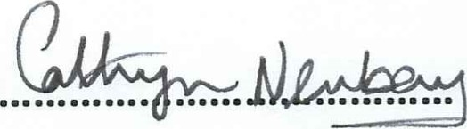Parish Clark
Verifie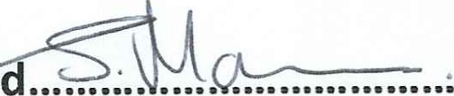Parish Council Chairman

This document published on the Parish Council website no later than 30th June following the reported year.

