Clyst St George P.C. Planning Comments 23/0696/FUL

The concept of the glamping units is innovative, with visitors living ‘off-grid’ surrounded by nature in the heart of the countryside. Unfortunately, we feel that the this is not an appropriate location for the units and the proposal is contrary to our Neighbourhood Plan, Policy CSG4 as it would have an adverse impact on the ecology of the parish.
We note that the applicant’s ecological appraisal is restricted to the roadside hedgerow. However, the hedgerow along the ridge is centuries old, as it was the boundary between the parishes of Clyst St George and Woodbury, and such boundary hedgerows should be preserved as they are a valuable habitat for small mammals and birds.
The location of the units, on the ridge between the villages of Clyst St George and Ebford and to the east of a copse of mature (mainly oak) trees is an important, if not vital, breeding site for a number of bird species. Buzzards have been breeding there for many years and are regularly seen over the wood in the summer months. Similarly, ravens, owls and woodpeckers are no doubt breeding in this area as well as bats which are known to favour mature oak trees. The copse is seldom visited by anyone, as there is no public right of way near it, but Ebford residents do enjoy the view of the birds and the trees on the ridge.
The use of the glamping units in this location during the summer months/school holidays, with children naturally wishing to explore the woodland, would create a very real disturbance to the wildlife in this area.
We also have concerns regarding access from the B3179 Woodbury Road as the entrance is on a bend which, with a wider visibility splay, will give motorists a better view with the likely consequence of an increase in speeding vehicles along this road. Moreover, the realignment of the hedgerow to create this entrance is extensive, with adverse repercussions for wildlife in this area.
The disposal of waste water is also an issue as the soil in this area is an impervious, heavy clay.
A further concern is the type of surface used for the track which should not blight the beauty of the natural landscape.
As a Parish Council we are not opposed to the concept of glamping units, but feel, due to the concerns outlined above, that the location is not appropriate. It would perhaps be more suitable for the units to be located closer to facilities for waste disposal and with better access.

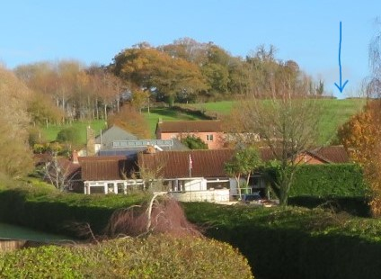
Arrow points to gateway mentioned in Location of units. Viewed from the south (Ebford).

